|  |  |
| --- | --- |
| **Ex. No: 6** | **Web Server Creation using NodeJS** |
| **21.09.2023** |

**Aim:**To Create a Web Server offering basic web service(s) to the front-end.

**Algorithm:**

1. Ensure you have Node.js installed on your system.
2. Develop a JavaScript file (e.g., server.js) for your web server.
3. In server.js, require Node.js's built-in http module using require('http').
4. Use the http.createServer() method to create an HTTP server, specifying a request handling function.
5. Inside the request handling function, use the request and response objects to define how your server should respond to different routes and HTTP methods.
6. Test your web server using tools like cURL or Postman. Debug and refine your route handling as needed.
7. Optionally, configure the web server to serve static HTML, CSS, and JavaScript files if your front-end includes them, using the fs (file system) module.

**Program:**

**Server.js**

const http = require("http");

const fs = require("fs");

const path = require("path");

const url = require("url");

const server = http.createServer((req, res) => {

const reqUrl = url.parse(req.url, true);

if (reqUrl.pathname === "/" || reqUrl.pathname === "/index.html") {

// Serve the HTML page

fs.readFile(path.join(__dirname, "public", "index.html"), (err, data) => {

if (err) {

res.writeHead(500, { "Content-Type": "text/plain" });

res.end("Internal Server Error");

} else {

res.writeHead(200, { "Content-Type": "text/html" });

res.end(data);

}

});

} else if (reqUrl.pathname === "/styles.css") {

// Serve the CSS file

fs.readFile(path.join(__dirname, "public", "styles.css"), (err, data) => {

if (err) {

res.writeHead(500, { "Content-Type": "text/plain" });

res.end("Internal Server Error");

} else {

res.writeHead(200, { "Content-Type": "text/css" });

res.end(data);

}

});

} else if (reqUrl.pathname === "/script.js") {

// Serve the JavaScript file

fs.readFile(path.join(__dirname, "public", "script.js"), (err, data) => {

if (err) {

res.writeHead(500, { "Content-Type": "text/plain" });

res.end("Internal Server Error");

} else {

res.writeHead(200, { "Content-Type": "text/javascript" });

res.end(data);

}

});

} else if (reqUrl.pathname === "/notes" && req.method === "GET") {

// Handle GET request to retrieve notes (simulated in-memory storage)

const notes = [

{ id: 1, text: "Buy groceries" },

{ id: 2, text: "Call John" },

];

res.writeHead(200, { "Content-Type": "application/json" });

res.end(JSON.stringify(notes));

} else {

// Handle other routes with a 404 Not Found response

res.writeHead(404, { "Content-Type": "text/plain" });

res.end("Not Found");

}

});

const port = process.env.PORT || 3000;

server.listen(port, () => {

console.log(`Server is running on port ${port}`);

});

**Index.html**

<!DOCTYPE html>

<html lang="en">

<head>

<meta charset="UTF-8">

<meta name="viewport" content="width=device-width, initial-

scale=1.0">

<title>Server-Side Notes</title>

<link rel="stylesheet" href="styles.css">

</head>

<body>

<h1>Server-Side Notes</h1>

<div class="notes-container">

<textarea id="noteInput" placeholder="Add a new note">

</textarea>

<button id="addNote">Add Note</button>

</div>

<div class="notes-list">

</div>

<script</body>

</html>

src="script.js"></script>

**Script.js**

document.addEventListener("DOMContentLoaded", () => {

const noteInput = document.getElementById("noteInput");

const addNoteButton = document.getElementById("addNote");

const notesList = document.querySelector(".notes-list");

// Fetch and display notes

fetch("/notes")

.then((response) => response.json())

.then((notes) => {

notes.forEach((note) => {

displayNote(note);

});

})

.catch((error) => {

console.error("Error fetching notes:", error);

});

// Add a new note

addNoteButton.addEventListener("click", () => {

const text = noteInput.value.trim();

if (text) {

fetch("/notes", {

method: "POST",

headers: {

"Content-Type": "application/json",

},

body: JSON.stringify({ text }),

})

.then((response) => response.json())

.then((newNote) => {

displayNote(newNote);

noteInput.value = "";

})

.catch((error) => {

console.error("Error adding note:", error);

});

}

});

// Display a note

function displayNote(note) {

const noteElement = document.createElement("div");

noteElement.className = "note";

noteElement.textContent = note.text;

notesList.appendChild(noteElement);

}

});

**Output:**

Github Link: https://github.com/AsHtrich/Web_tech2023

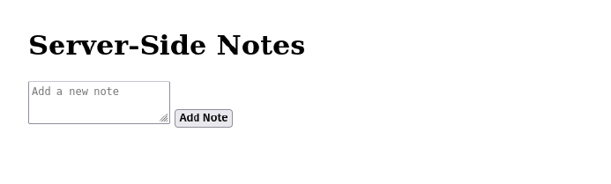

Server Side output:

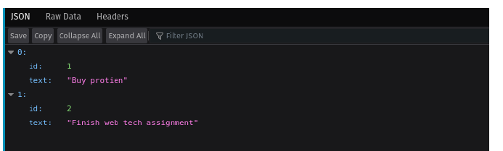

**Result:**

Therefore, we've successfully implemented a web server backend using NodeJS .